START

1/ before the upgrade to 4.44.82+a make sure the i-series already has 3.46.50 if it hasn’t first upgrade to 3.46.50

2/ use micro SD card, I used 32GB MicroSDHC  
  
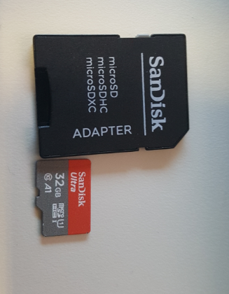

3/ format if needed with FAT32

4/ below the URL for images 3.46.50 and 4.44.872+a

3.46.50

<https://elotouch.sharepoint.com/:u:/s/EMEAFAE/Eb34fGW1785CkKeQte8dXqIBOfWqL9eQmbxZA69stu2yvg?e=xXkZMo&download=1>

4.44.82+a

<https://elotouch.sharepoint.com/:u:/s/EMEAFAE/Ec9n7Gnr3MZLmsKfZXxy7GsBJN2OYM1f1-zcVhpSn_YZQw?e=ugEcGH&download=1>

**5/ upgrading from 3.xx to 3.46.50**

- remove power from i-series

- copy 3-46-50.zip to SDCARD  
- insert SDCARD into i-series SDCARD slot

- press and hold down the home button and while keeping it pressed power the i-series.  
The power LED will start blinking, keep the home button pressed until it stops blinking and below screen will appear

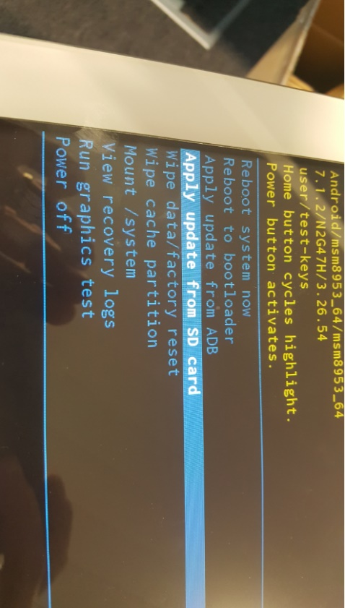

- select ‘Apply update from SD card’ with the i-series home button and confirm the selection with the power button.

Below screen will appear.  
  
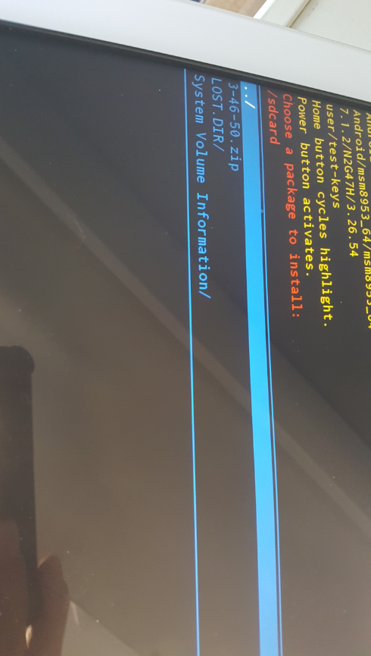

- select the 3.46.50.zip with the home button and confirm with the power button

You will see below and let it run.  
  
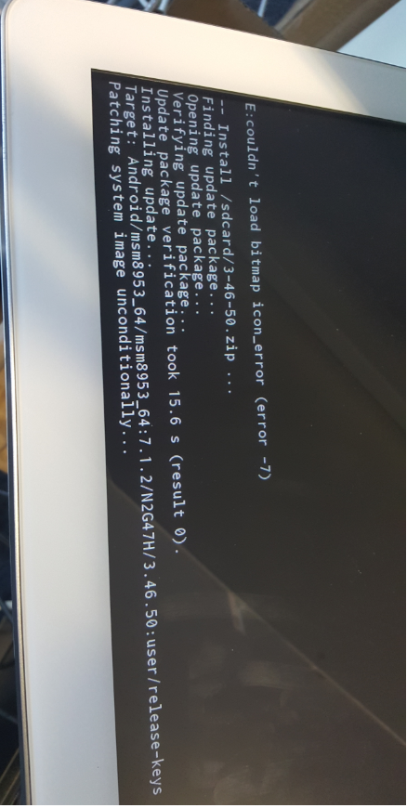

The unit will reboot, press settings in the menu bar and you will see below version

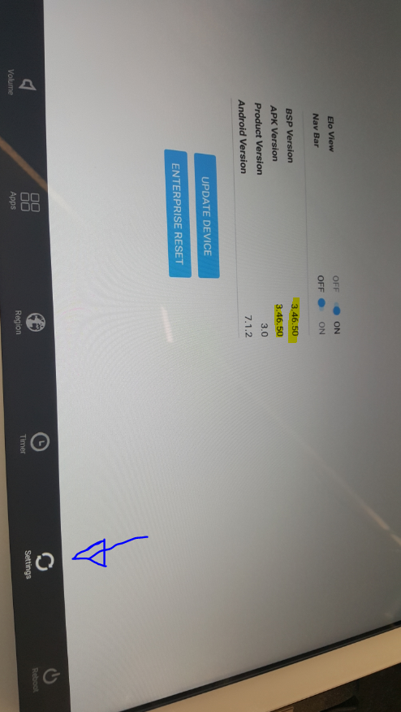

**6/ upgrade to 4.44.82+a**- remove power from i-series

- format SDCARD with FAT32

- copy 4.4.82+a.zip to SDCARD

- **rename it to update.zip**

- insert SDCARD into i-series

- Hold home key and power on the device to start Auto-update using recovery mode.,  
Release home key once OTA installation gets started by Recovery and progress gets visible on the screen, see below screen (might be that it disappears and re-appears) and let it run  
  
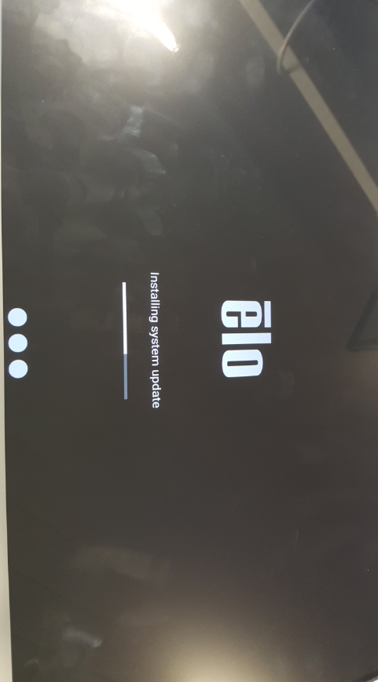

- The unit will reboot

Press home, keep it pressed and then power button

- control panel will appear, password is *1elo*

- check in settings the version

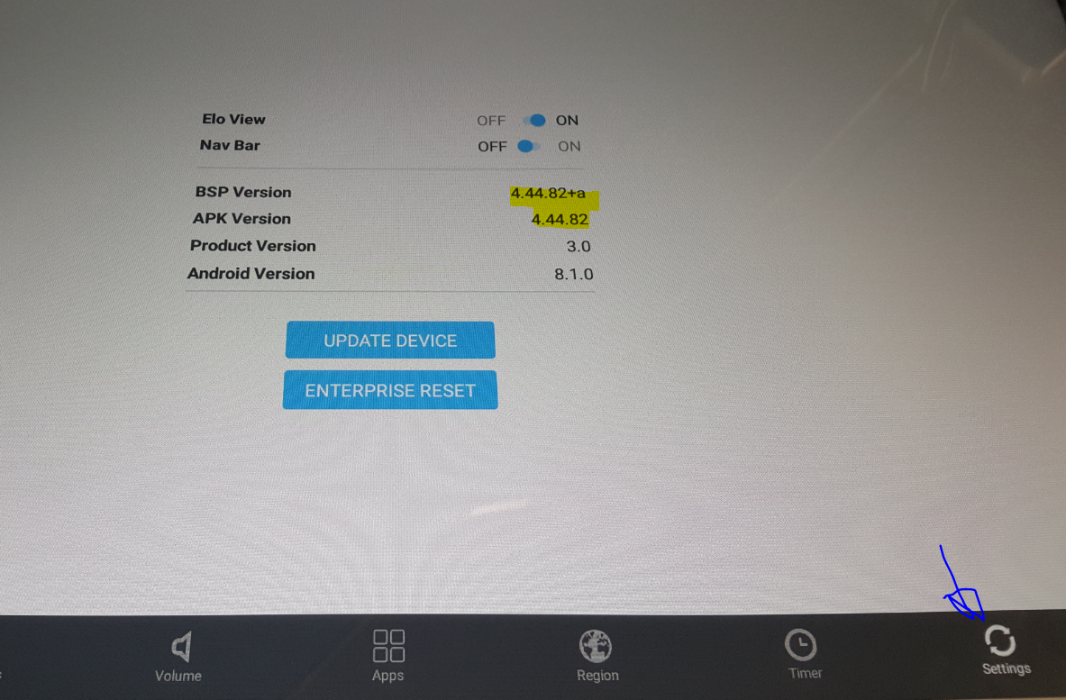

END