**How to use NCR imaging suite software with EloPOS**

Notes:

* Network rules should allow UDP port 137 for NetBIOS traffic
* Network adapter should allow NetBIOS over TCP/IP
* Network shared folder (location to store and deploy captured images)
* Windows server or workstation
* No other DHCP service should exist on the network segment
* Works with and without a network gateway
* When adding additional drivers to Boot.wim, maintained file under 400MB

Imaging Suite Download:  
<https://www5.ncr.com//support/support_drivers_patches_radiant.asp?Class=Hospitality/GenDrivers_display> v5.4.0.4

Content of File:

* Prerequisites
* PXEBOOT-WINPE
* Recovery_Update
* Utilities
* NCR Imaging Suite User Guide.doc
* ReleaseNotes.txt

Instructions:

1. Connect **server** “PXE server” and **EloPOS** “PXE client” on the same network segment
2. On the PXE server, assign an IPv4 static address of **10.10.10.2**, subnet mask 255.255.255.0, gateway 10.10.10.1, DNS 8.8.8.8, 8.8.4.4
3. Create a network shared folder labeled **“Images”**
4. Go into the folder \PXEBOOT-WINPE\UEFI\ and launch **tftpd32.exe**
5. Configure the **TFTP tab** with the settings shown below

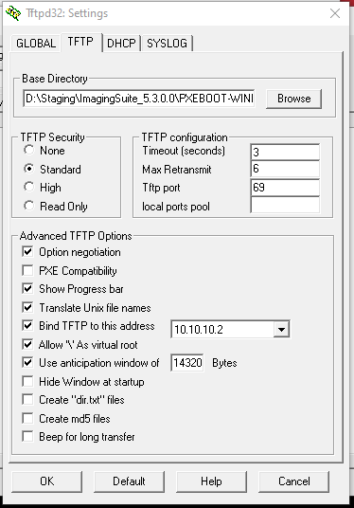

1. Next, configure **DHCP tab** with the settings shown below

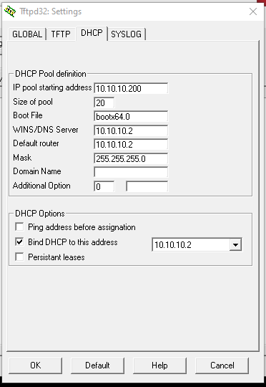

1. On the Tftpd32 main window, select the server interface **10.10.10.2**

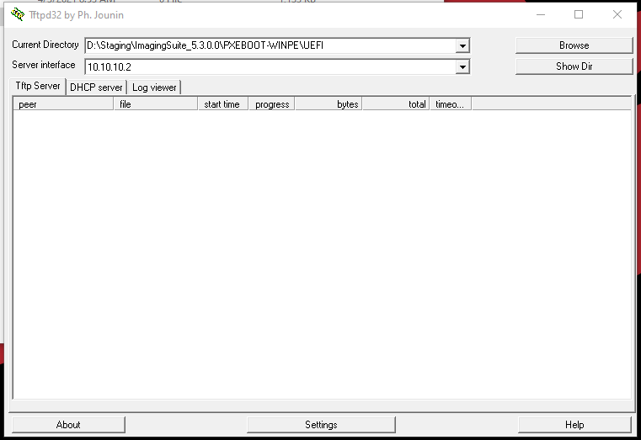

1. Go to the folder \ImagingSuite_5.4.0.4\Utilities\ and launch **ImagingServer.exe**
2. Select **Capture** or **Apply Image**. In this example, we have a captured image ready.
3. Click **Choose Share** and select the “Images” network shared folder
4. Enter credentials allowed to access the shared folder
5. Click **Browse** to select a previously captured image (.wim)
6. Click **Start**

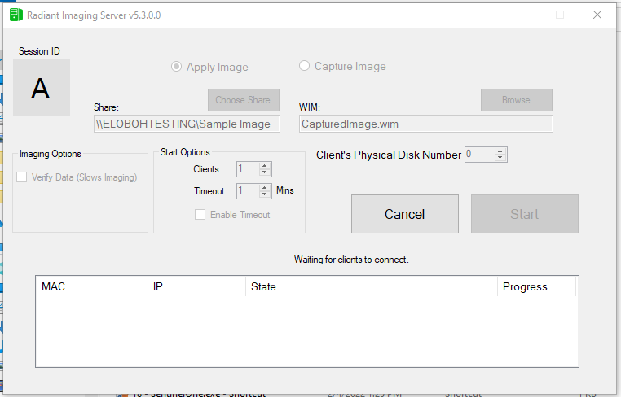

1. On the PXE client, **enabled PXE boot** and **UEFI mode** in the BIOS settings
2. Perform an **IPv4 network boot**
3. Wait for the PXE client to receive a DHCP address from the PXE server
4. Wait for PXE client to download boot.wim boot file.
5. Wait for PXE client to enter pre-boot environment and load network driver.
6. Wait for PXE client to automatically launch ImageClient.exe
7. Choose to **Connect** to NCR server
8. If the IP address of the PXE server appears, the PXE client is ready to receive an image.

Other notes:

* When boot.wim is larger than 400MB, EloPOS will crash. Remove unnecessary drivers to reduce the size of the file. Use DISM utility in Windows to modify and cleanup .wim files.
* ImagingServer.exe will use NetBIOS service to communicate with ImageClient.exe