Preparing Windows 11 to Flash M60

This guide does not provide complete steps for flashing M60 and is intended to show how to install the device driver before the device can be flashed. It is recommended to install applicable Windows Updates including optional drivers before starting. Obtain an USB-A to USB-C or USB-C to USB-C cable. Not all USB-C cables are compatible.

- Boot the M60 into Fastboot mode by holding down the trigger button underneath the power button, then connect the device to the PC.
- When the LED light finishes flashing, release the trigger button. The device will enter Fastboot mode.
- On the PC, open the Device Manager and notice the unknown Android device.

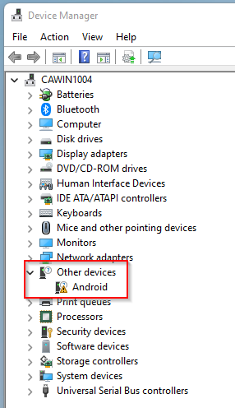

- Open Windows Updates and then click Check for updates.
- Click Advanced options.

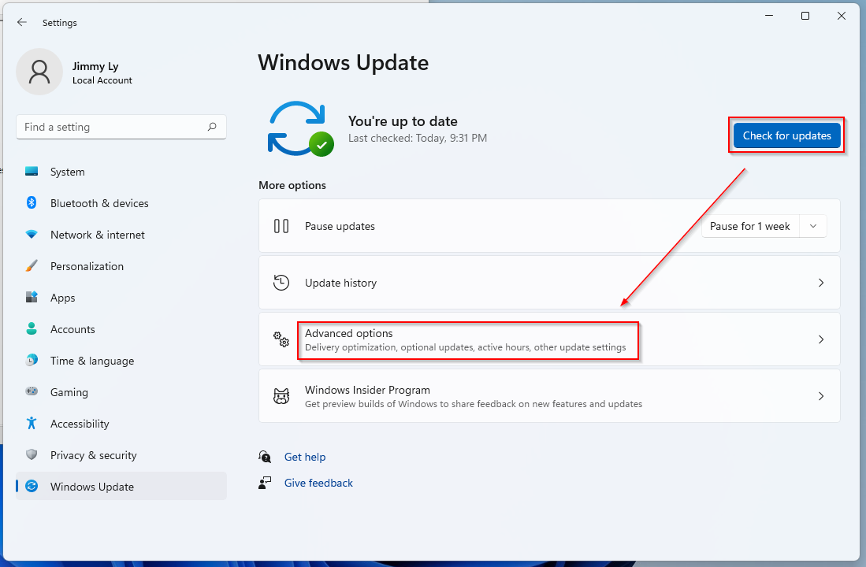

- Click Driver updates.
- Select the driver "Google, Inc. - Other hardware - Android Bootloader Interface" and then download and install.

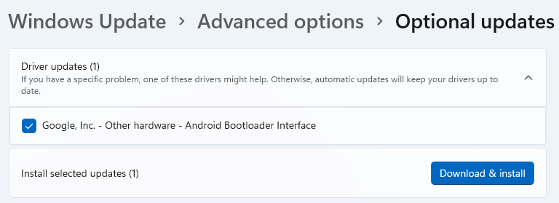

- The unknown Android device in Device Manager will become "Android Bootloader Interface" under the Kedacom USB Device group.

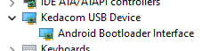

- Obtain an M60 image or the Android platform-tools containing fastboot.exe. Extract files.
- Open a command prompt window and change the directory to the M60 image folder.
- Run the command “Fastboot devices”.
- If the result returns with the serial number of the device, the computer is ready to flash the device.

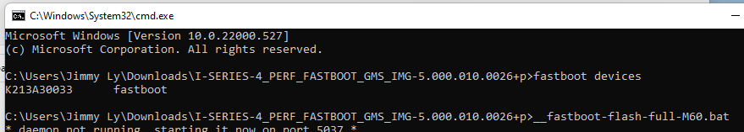

Notes:
- When the device is not in Fastboot mode, the M60 will be listed as M60C-Pay under the Portable Devices group in Device Manager.
- The driver may also list under Windows Updates as "LeMobile - Other hardware - Android Composite ADB Interface".

