Checking if touch driver is included in a specific driver pack version
Note: Elo touch driver does not support monitor by model number but by the controller type that goes inside. The reason is there are many model #s and even with the same monitor model, a different touch controller can be put in depending on the touch technology configuration.
Elo touch driver support by controller VID (vendor ID) and PID (Product ID).
VID and PID can be found in Device Manager with or without the Elo driver installed.
Most of Elo VID is 04E7, except a few third-party controllers that have not been changed including the Atmel controller below showing 03EB, PID is 8A6E and FW is 1034.
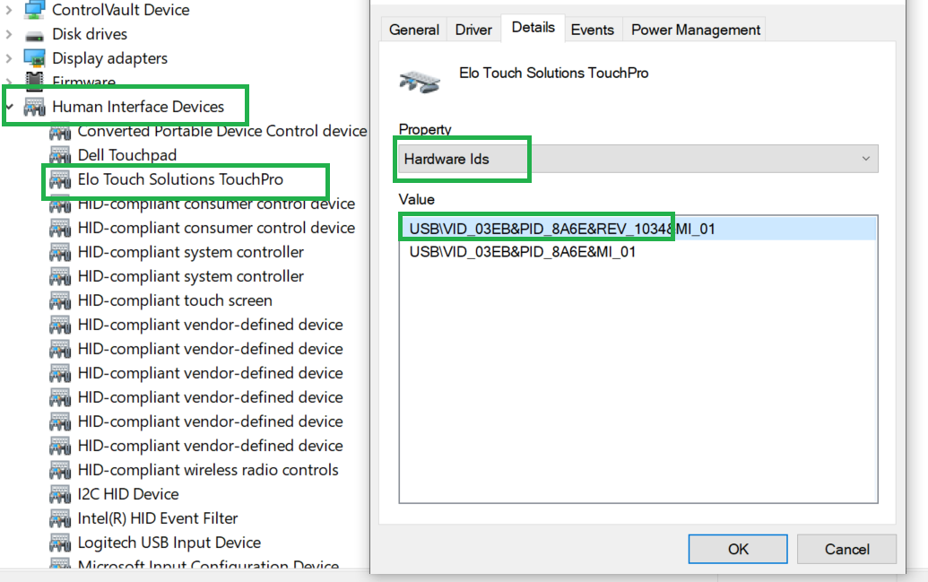
The touch drivers from the Elo website are self-extractor files that can be unzipped, without installing the driver by unchecking on Setup.exe. In the unzipped folder, you can find the EloMTUSB.inf file. It lists all supported PIDs in that driver package. Shown below is an example of one taken from SW602660_EloMultiTouch_6.9.23.exe
If the VID and PID in the Device Manager matches with the VID/PID in the .inf file, then that driver supports that controller.
The entry for VID/PID in .inf file for Atmel controller would look like this:
%EloTouchUsb03EB.8A6E.DeviceDesc% =EloMTUsbInst.Win7, USB\VID_03EB&PID_8A6E&MI_01
The rule of thumb is the newer the driver, new controller PIDs are supported including PCAP. When in doubt, use the latest driver version.
MT 8.0.0 was recently released to support Windows 7/8/8.1/10/11.

