# OneLogin Setup in Polaris

* Login to **OneLogin Dashboard**:- <https://app.onelogin.com/login>
* 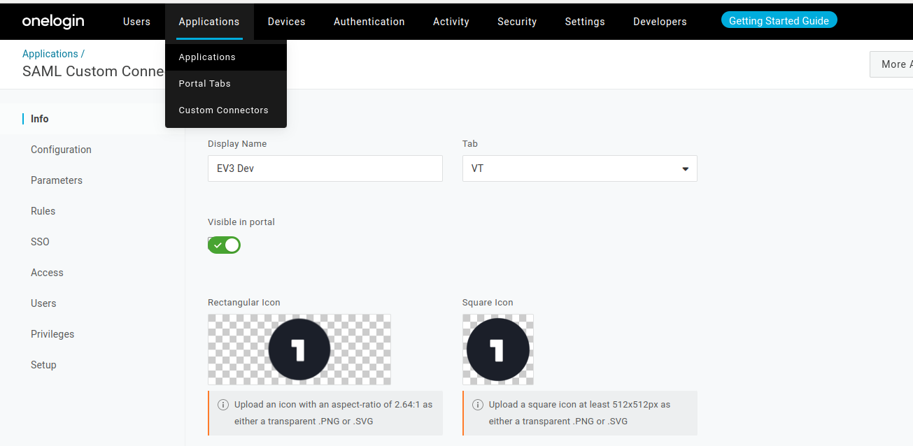Navigate to the **Applications page**
* Navigate to the **SSO page ->** Copy the **Issuer URL**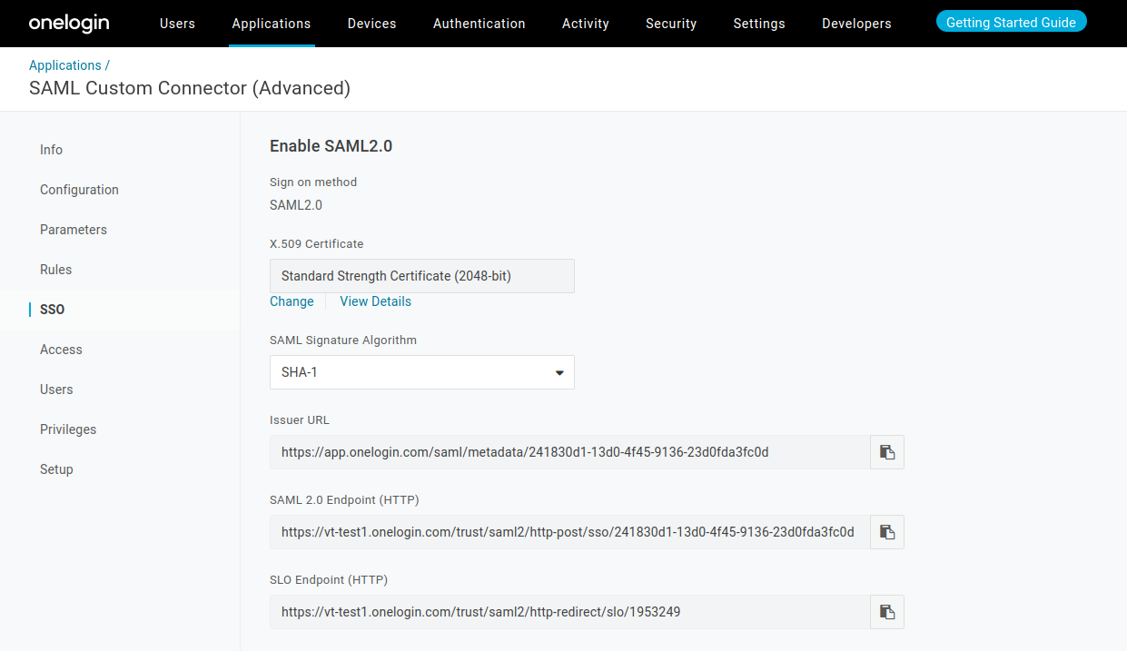
* Visit the **EloView4(Polaris) UI ->** [**https://secure.eloview.com/**](https://secure.eloview.com/)
* Navigate to the **Account Details page -> Go to SAML tab**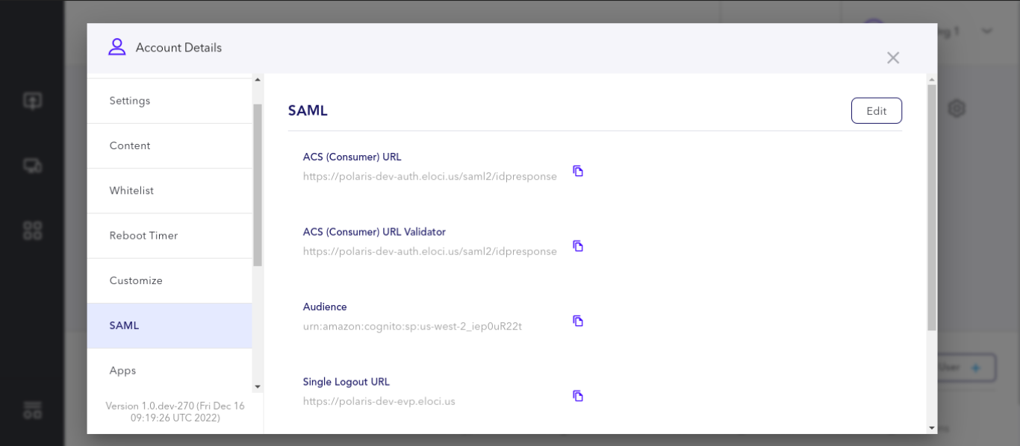
* Click on the **Edit Button**
* Paste the copied **Identity Provider Issuer URL** in the **Metadata URL** input field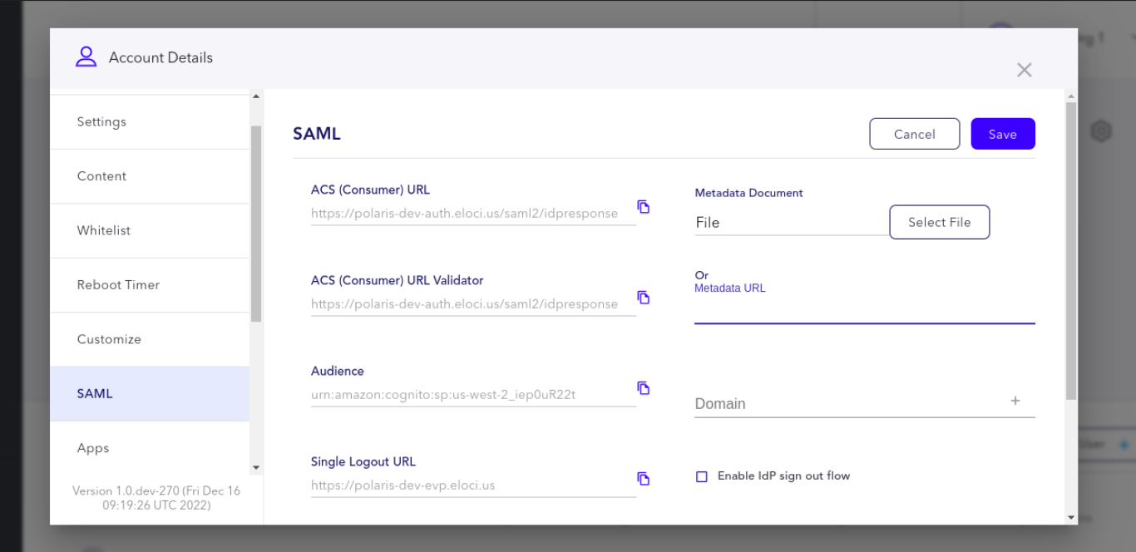
* Add the **Domain used** in **SAML User's emails**
* Check the **Enable IdP sign out flow** checkbox and Click on the **Save button**

**Update the SAML SSO Details in OneLogin**

* Copy the **ACS(Consumer) URL** and **Audience** details
* Go to **OneLogin Dashboard** **->** **Applications page**
* Navigate to the **Configuration tab**
* Paste the **ACS(Consumer) URL , AudienceL, Audience** details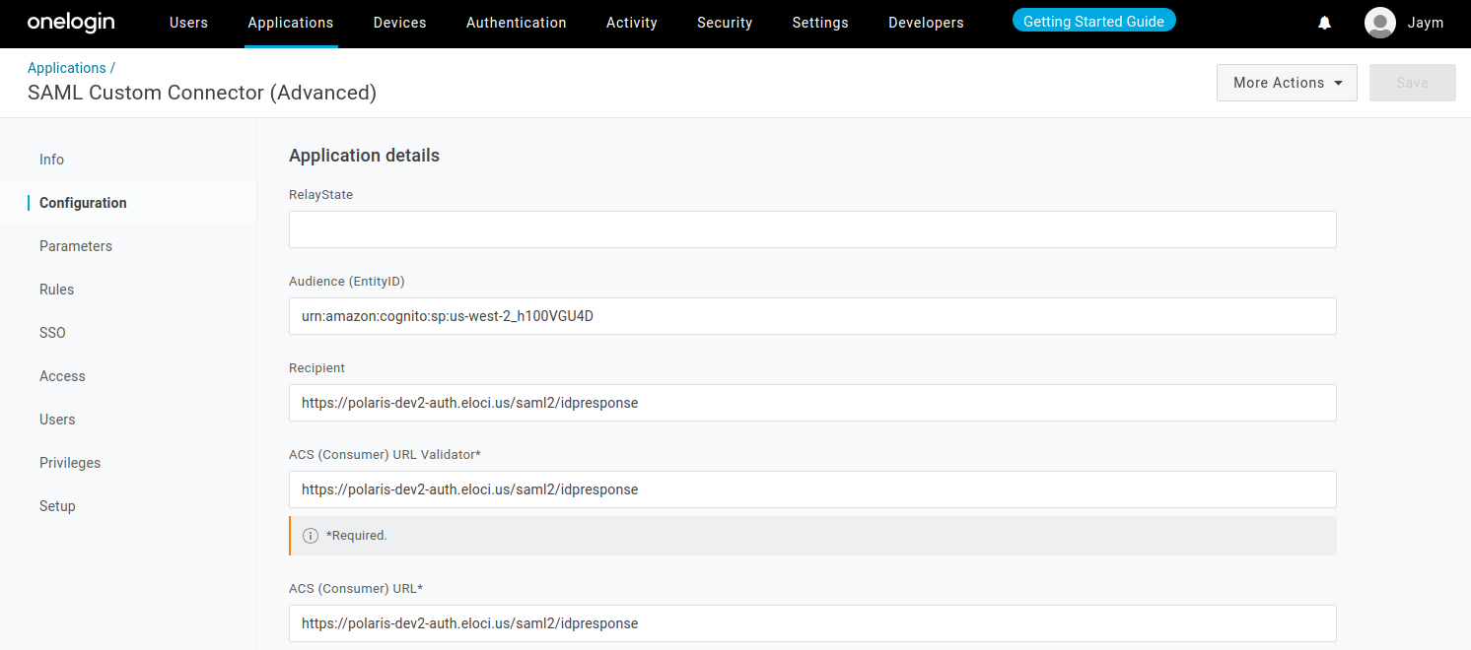
* Paste the **ACS(Consumer) URL** in the **Recipient** field
* Click on **Save Button** to save the changes with this the SAML setup is complete for OneLogin.

# 

# OneLogin SAML App modifications (In OneLogin Dashboard)

* Login to **OneLogin Dashboard**:- <https://app.onelogin.com/login>
* Navigate to the **Users page -> Custom User Fields** section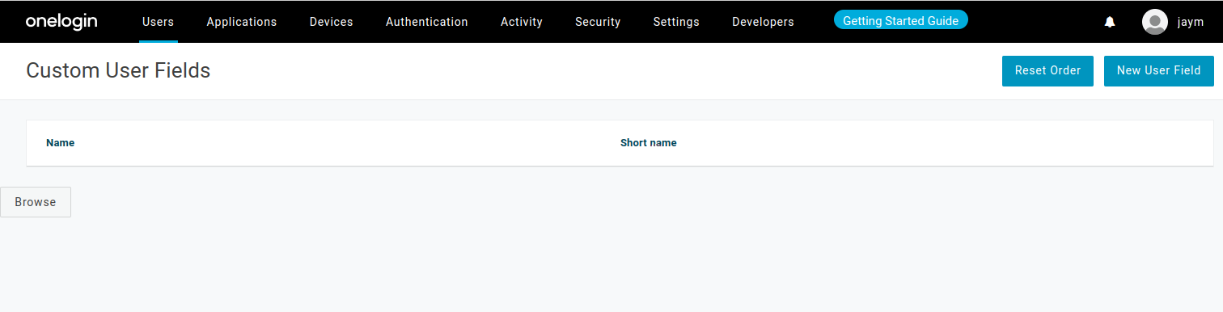
* Click on the **New User Field button**
* **Add** the custom field **elo_orgId** as shown below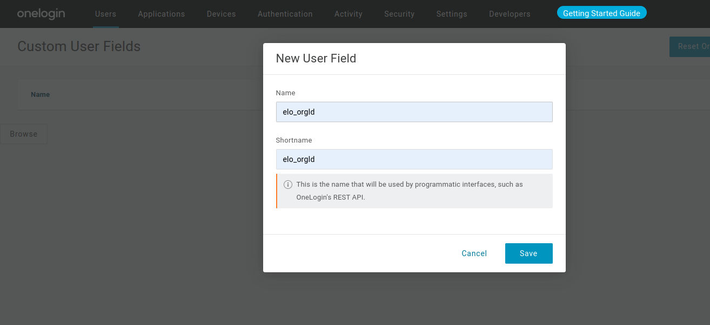

* **Add** the custom field **elo_role** as shown below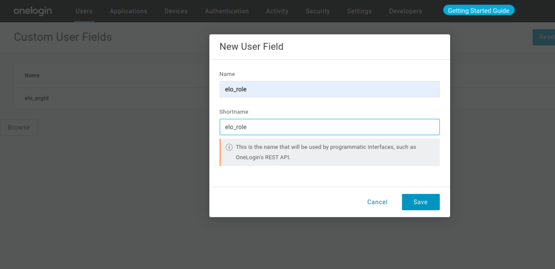
* These **Custom User Fields** are needed in the Polaris SAML login process.
* Navigate to **Application Tab -> SAML Application used for EloView3**
* Go to the **Parameters section**
* Need to map the newly added **Custom Fields** with **SAML Application used for login. Click** the **plus icon(+)** asshown below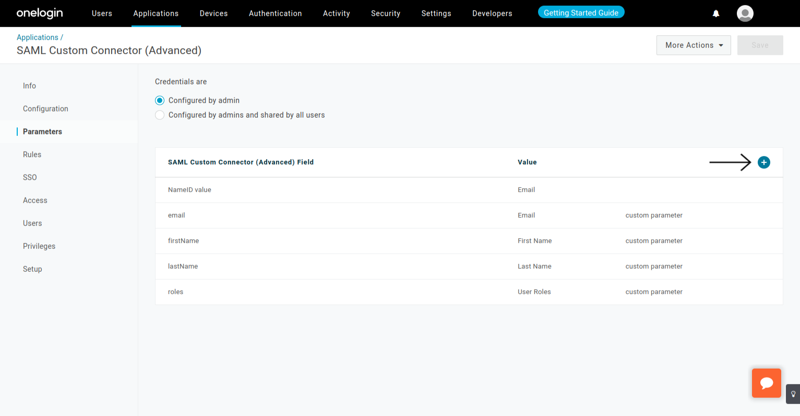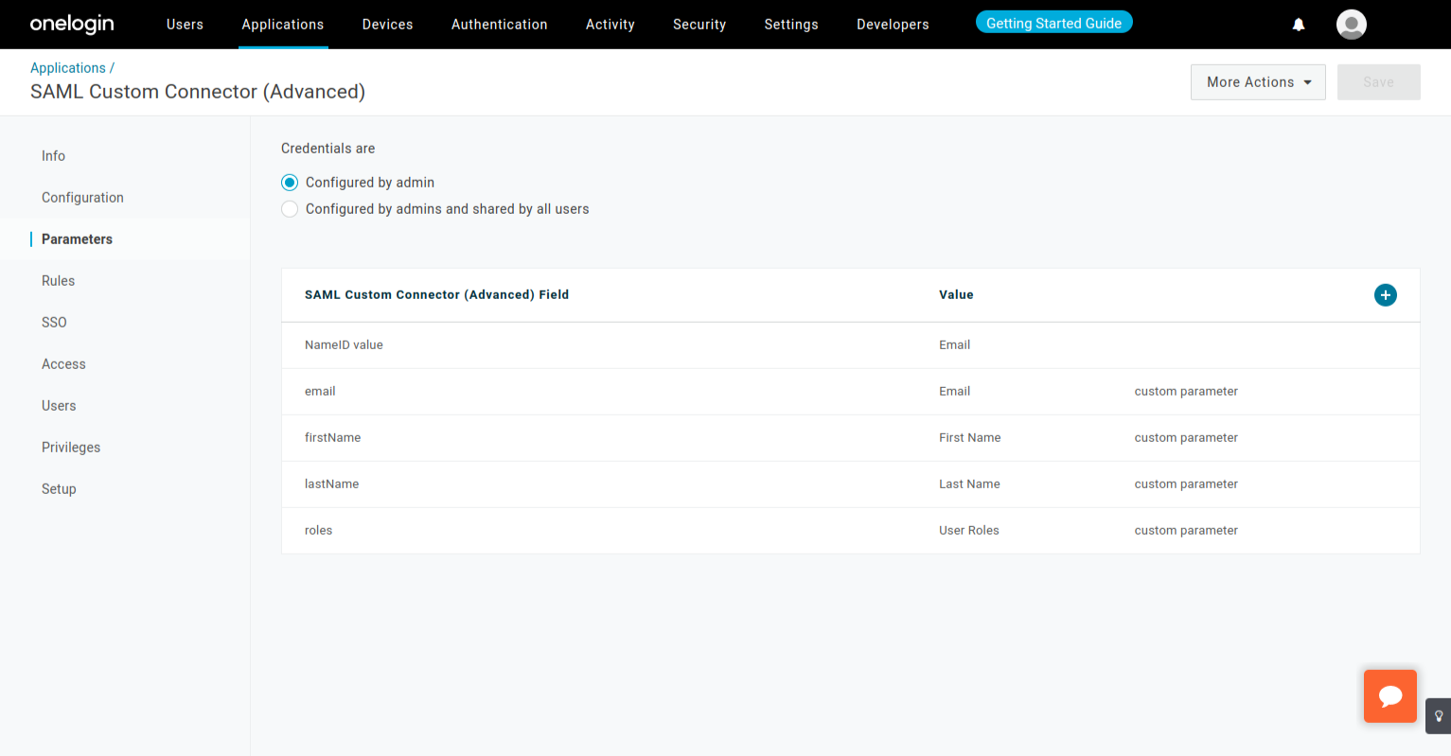
* Add **Field name -> elo_orgId** and **select** the **Include in SAML assertion checkbox.** Then **click** the **Save button**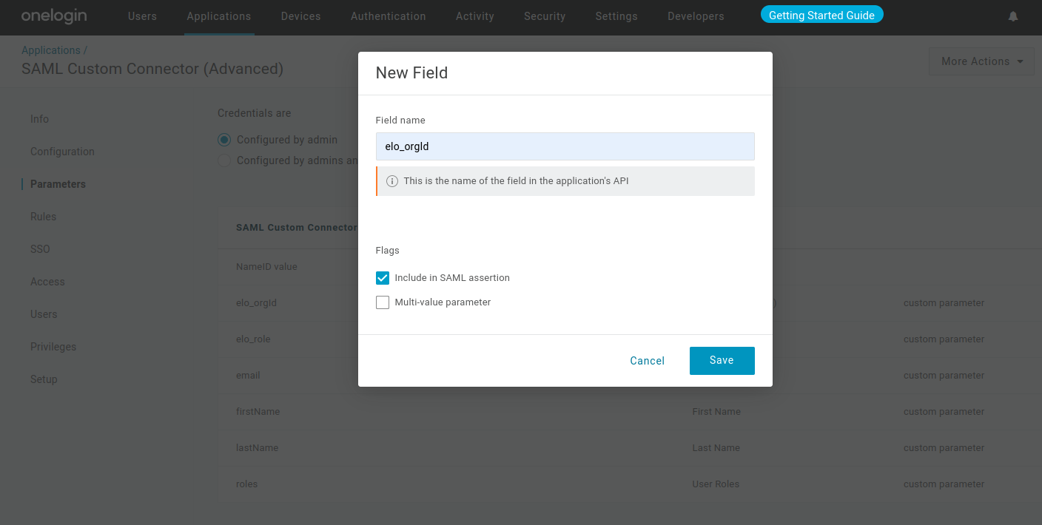
* Select the mapping value **elo_orgId (Custom)** **from the dropdown** as shown below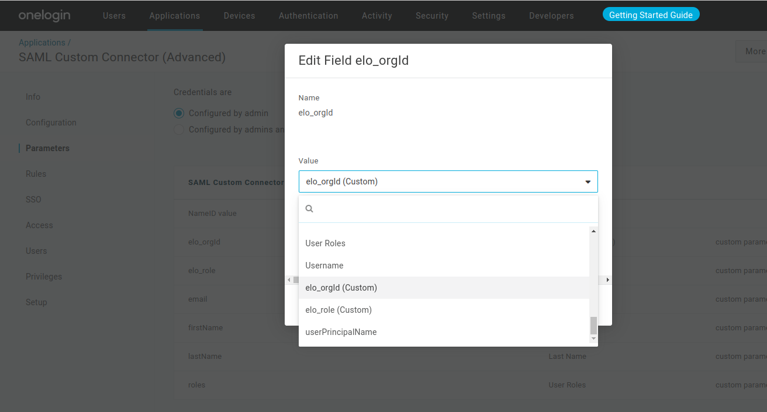
* Need to map the newly added Custom Fields with SAML Application used for login. **Click** the **plus icon(+)** as shown below
* Add **Field name -> elo_role** and **select** the **Include in SAML assertion checkbox.** Then **click** the **Save button**

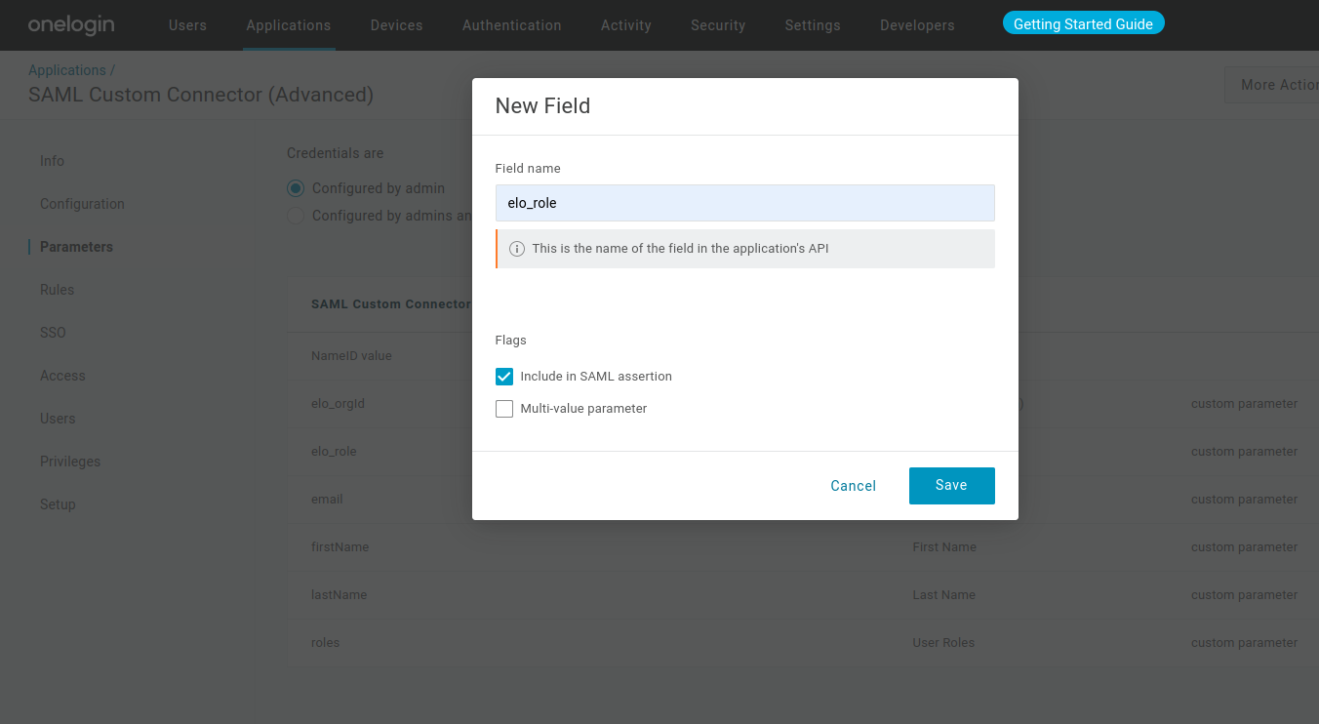

* Select the mapping value **elo_role** **(Custom)** from the dropdown as shown below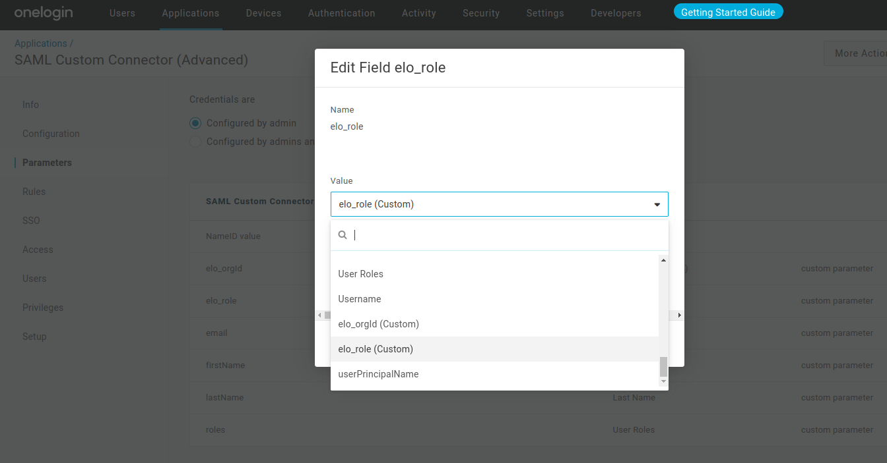
* Click on **Save Button,** Tosave the newly added mappings
* Navigate back to the **Users tab**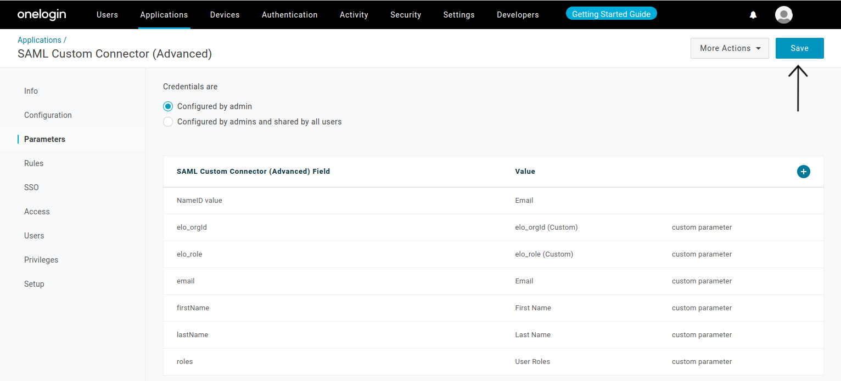
* Select the **User Entry** to modify for Polaris login.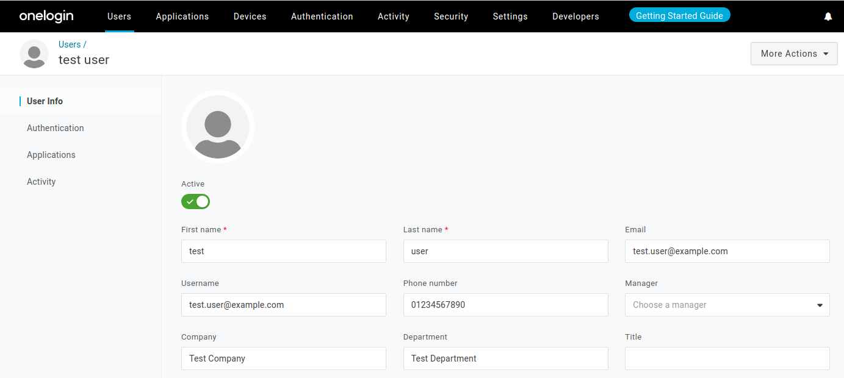
* Go to the **Application Tab,** **Click** on the **plus icon (+) as shown below**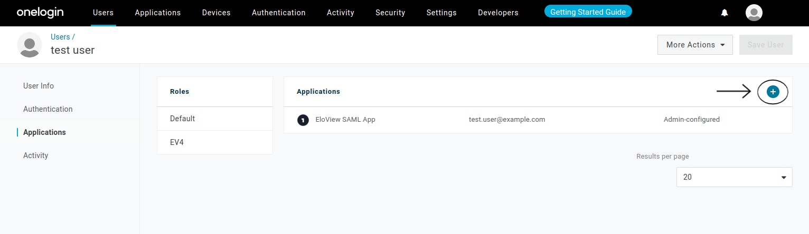
* The **Edit Login dialouge** will be opened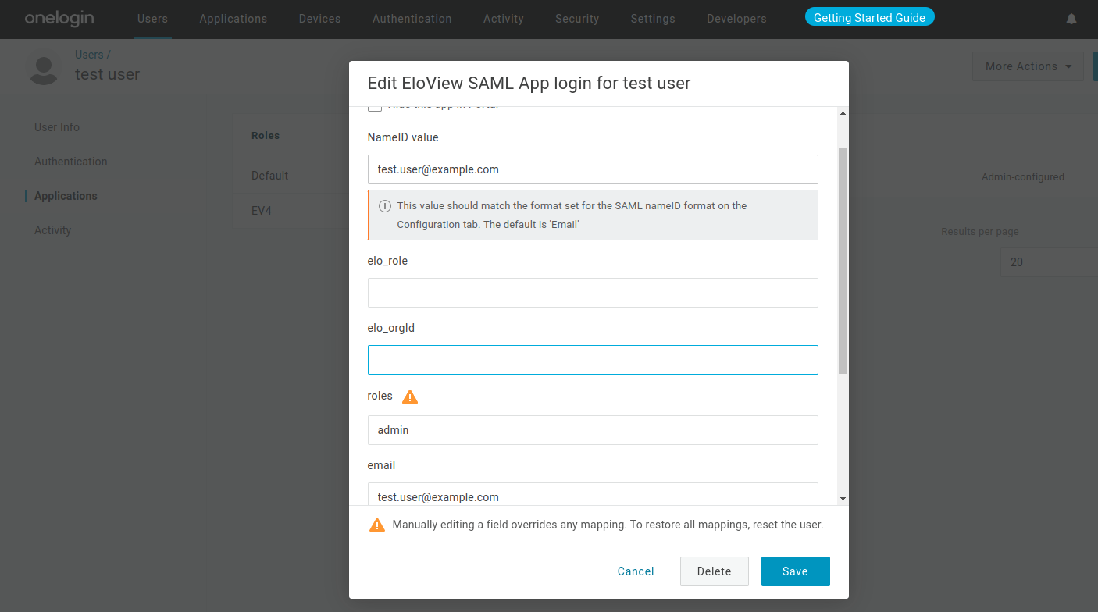
* **In a separate tab**, Visit the **EloView4(Polaris) UI -> <REPLACE_WITH_POLARIS_PROD_URL>**
* Navigate to the **Account Details page -> Go to SAML tab**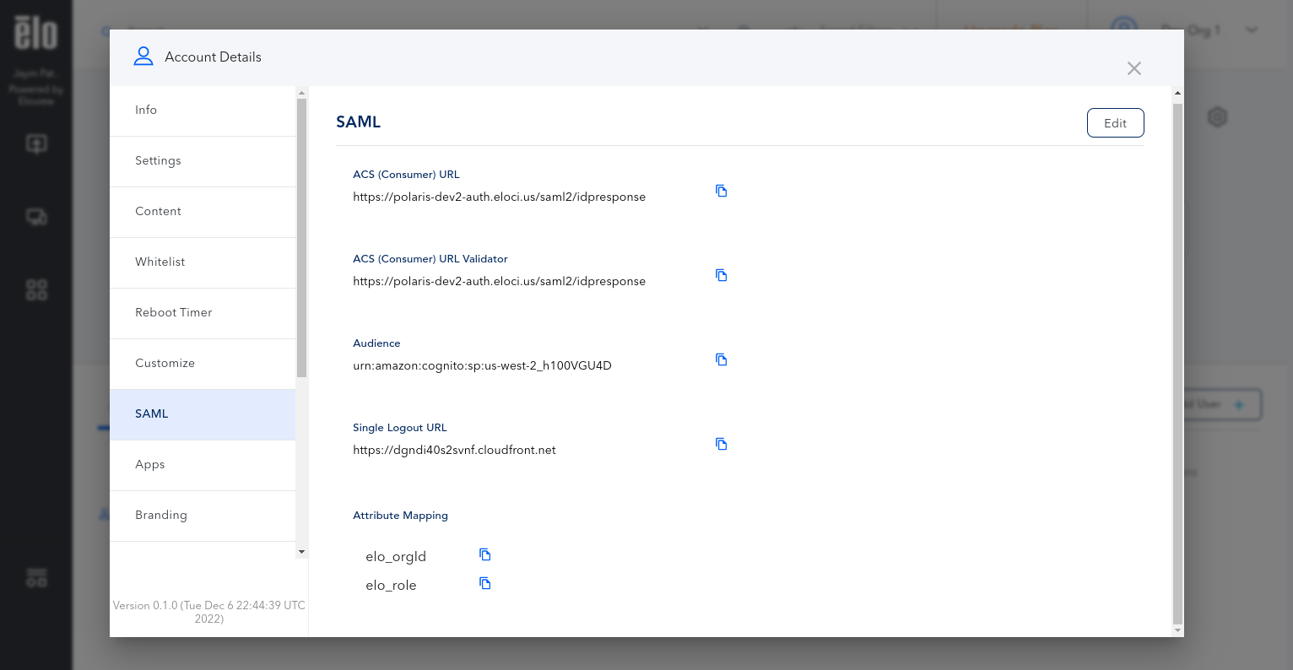
* Copy the **elo_orgId** from the **Copy Button**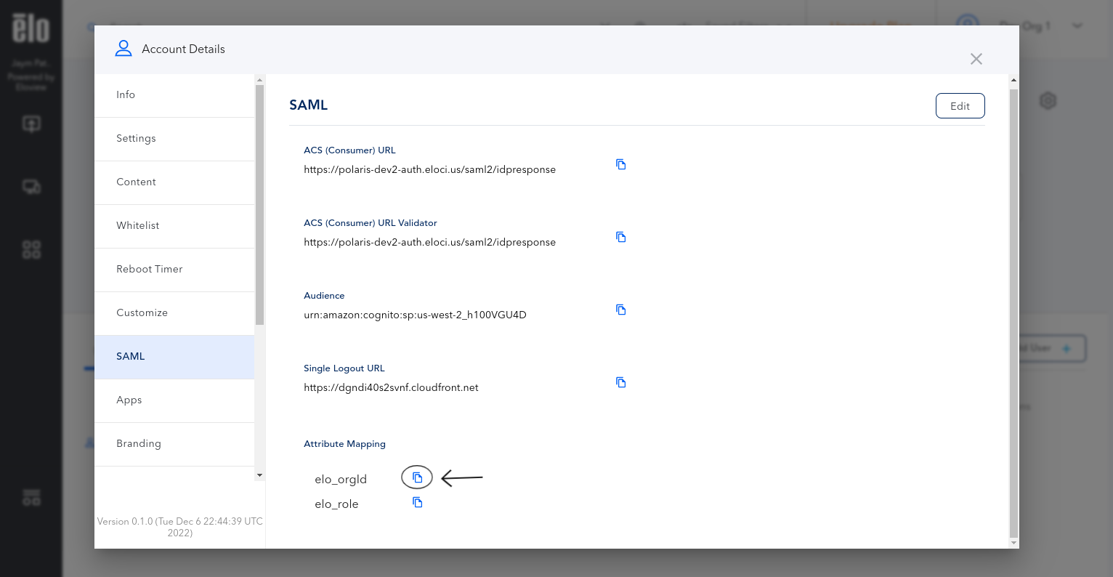
* **Paste** the copied **elo_orgId** in the **Edit Login dialouge**
* Copy the **elo_role** from the **Copy Button**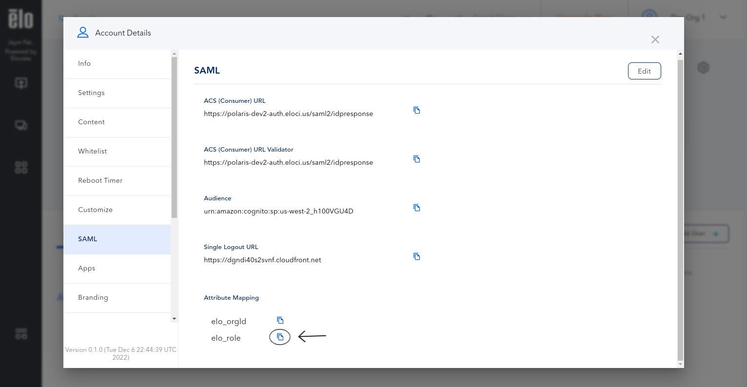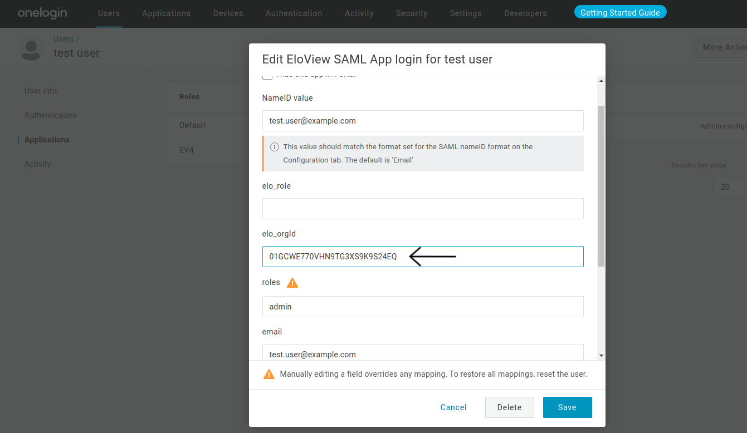
* **Paste** the copied **elo_role** in the **Edit Login dialouge**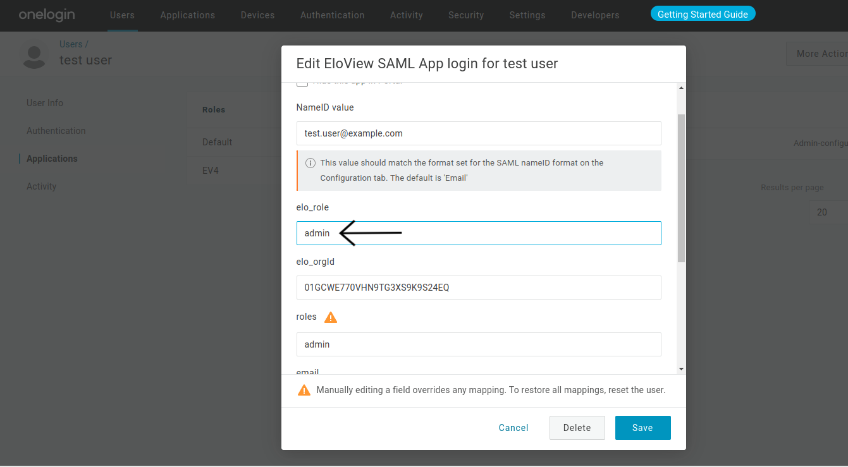
* **Click** on the **Save Button**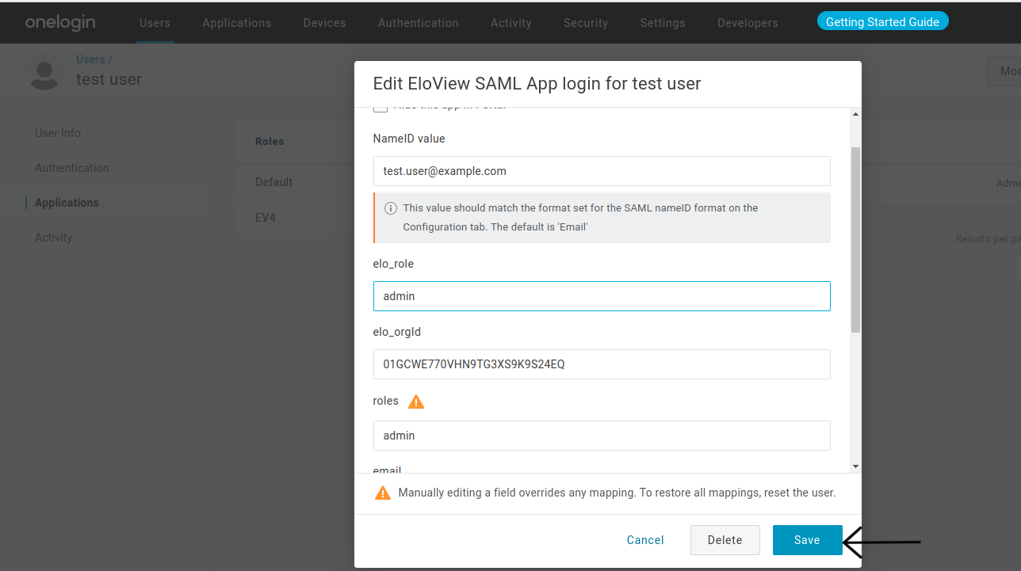
* After this user should be able to **Log In via SAML**